A1: Show that if x, y, and z are positive integers, then 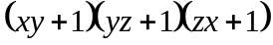 is a perfect square if and only if 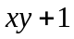, 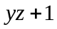, and 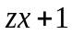 are all perfect squares.

Proof:

Pf (part 1):

Assume,, and are all perfect squares.
Prove is a perfect square.

Theorem: If integer 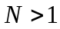is not a perfect square, then 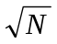is irrational.
Contrapositive: If is not irrational, then integer is a perfect square. That is…If is rational, then integeris a perfect square.

Let 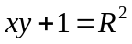, 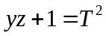 and 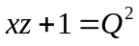

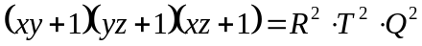
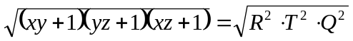
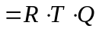
Recall: x, y, and z are positive integers
- R, T and Q are positive integers
- 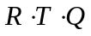is a positive integer and therefore is a rational number
Therefore: 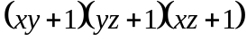is a rational number
- is a perfect square

Pf (part 2):

Proof by Contradiction:
Assume is a perfect square
Assume ~(,, and are all perfect squares).
- One of , , or is not a perfect square.

Using a truth table:
P = is a perfect square, Q = is a perfect square, R = is not a perfect square
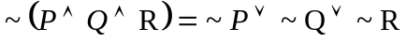
 | 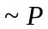 | 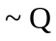 | 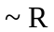 | 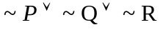
Case 1 | F | T | T | T
Case 2 | T | F | F | T

CASE 1: Without loss of generality, assume is not a perfect square. Assumeand are both perfect squares.

Since is a perfect square, can be written as a product of even-powered primes (otherwise the square root of the product would be an irrational number)

- = 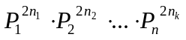 where P denotes a prime number

Since is not a perfect square, 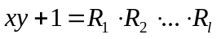, where 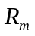 denotes a prime number. Because 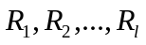are all factors of , they must also be factors of .
- 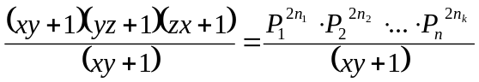 (Recall: x, y, and z are all positive integers, therefore 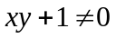

- 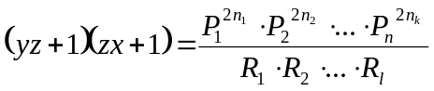

Recall: we stated that and are both perfect squares. This implies that the product of and must be written as a product of event-powered primes.

However, because is not a perfect square, it cannot be written as a product of event-powered primes. This implies that there is at least one prime-number factor that has an odd power (the square root of must be irrational).

Here we arrive at our contradiction, when we complete our simplification of our division, we are left with at least one odd-powered prime (due to cancellation), which contradicts our statement thatand are both perfect squares and is not.

Thus, , , and are all perfect squares.

CASE 2: Without loss of generality, assume is a perfect square. Assume and are not perfect squares.

= where P denotes a prime number

(Recall: x, y, and z are all positive integers, therefore )

Theorem: Any integer which is a ratio of perfect squares is a perfect square

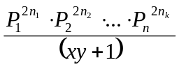 is a ratio of perfect squares (recall: x and y are positive integers, therefore is an integer. Therefore, after we reduce, what’s left will also be a perfect square since it is equal to the ratio of two perfect squares.

- 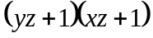 is also a perfect square

Theorem: Perfect squares always have an odd number of factors.

Theorem: Non-perfect squares always have an even number of factors.

- and will have an even number of factors
- will have an odd number of factors

The sum of the number of factors of and must equal the number of factors of.
Contradiction. Since an odd number cannot equal an even number, our original assumption must be incorrect.

Thus, , , and are all perfect squares

